Art Informel (Japan)

In Japan, Art Informel is more or less synonymous with the painting of the Gutai Art Association, which was founded in Osaka in 1954. The French term entered usage via the work of the critic and painter Michel Tapié, who arguably did most to market it as part of a larger international tendency — manifested as Tachisme (or the School of Paris) in France, CoBrA in Northern Europe, and Abstract Expressionism in Canada and the United States. In the painting of Gutai, there was much in common with the Tachisme promoted by Tapié, whose book *Un Art Autre* (1952) popularized the term.

In contrast to the flat hard-edge or post-painterly abstraction famously advocated by Clement Greenberg, Japanese Art Informel was a much more expressive and raw style of painting. It was mostly abstract and large scale, with surfaces characterized by impasto techniques, in which paint was applied directly, splashed, spilled or stained. This style was closer to what the critic Harold Rosenberg called action painting, in which the canvas (or other support) was used as an arena in which to *perform* the act of painting. The chance and accident so vital to Surrealism were also integral to the unmediated (or un-meditated) spontaneity of Informel. For many who adopted this style in Japan, the work of Jackson Pollock (as interpreted through Allan Kaprow’s notion of happenings) was a major point of inspiration.

As the elder spiritual leader and chief spokesperson of Gutai, Jiro Yoshihara was the main bridge between Informel in the West and in Japan. Yet it was the lesser known figure of Hisao Domoto, an expatriate who had moved to Paris in 1954, who first introduced Tapié and the painter Georges Mathieu to Gutai, during a touring exhibition, *Art of Today’s World,* which arrived in Osaka in 1958. Organized by Tapié, this exhibition marked a pivotal moment in Japanese post-war art. Henceforth, Gutai had a more international audience, and increasingly earned critical acclaim in Japan. The pace of cultural exchange quickened, with artists like Alberto Burri, Jean Fautrier, and Lucio Fontana gaining greater visibility in Japan, and works by Gutai being included in Informel shows at Paris’ Stadler Galerie and New York’s Martha Jackson Gallery. This reinforcement entrenched Informel among Gutai. Painters like Takesada Matsutani, Sadamasa Motonaga, and Tsuruko Yamazaki combined their technique with the physical properties of materials to determine the form — or the formlessness — of their work. One of the most representative of Informel artists in Japan, Kazuo Shiraga, went from his seminal happenings like *Challenging Mud*, 1955, in which he used the earth like paint and his body like a brush, to painting with his feet – sometimes even using a rope suspended from the ceiling to swing over canvases laid on the ground with puddles of oil-based pigment, predominantly blood reds and blacks – to create turbulent pictures of viscous swirls and abject splodges that bring to mind a primal creative violence or energy. Such works typify the aesthetic propulsions of the Informel movement in Japan.

References and further reading:

Hara, S. (2012) “Gutai and its Internationalism,” in, P. Schimmel, ed., *Destroy the Picture: Painting the Void, 1949-1962*, Milan: Skira Rizzoli, 204-211.

Havens, T. R. H. (2006) *Radicals and Realists in the Japanese Non-Verbal Arts: The Avant-Garde Rejection of Modernism*, Honolulu: University of Hawaii Press.

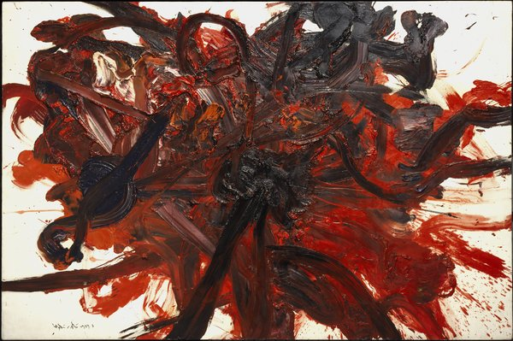

Kazuo Shiraga, *Untitled*, 1959, oil on canvas, 70.875 x 110 inches, Collection: Walker Art Center, T. B. Walker Acquisition Fund, 1998. Copyright retained by the artist